When you run this command on colab notebook you will get this as the output:

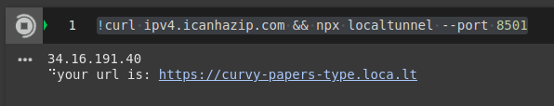

The first line is the password, and the second is your URL to access the streamlit app.

When you open the URL you will see the following window:  
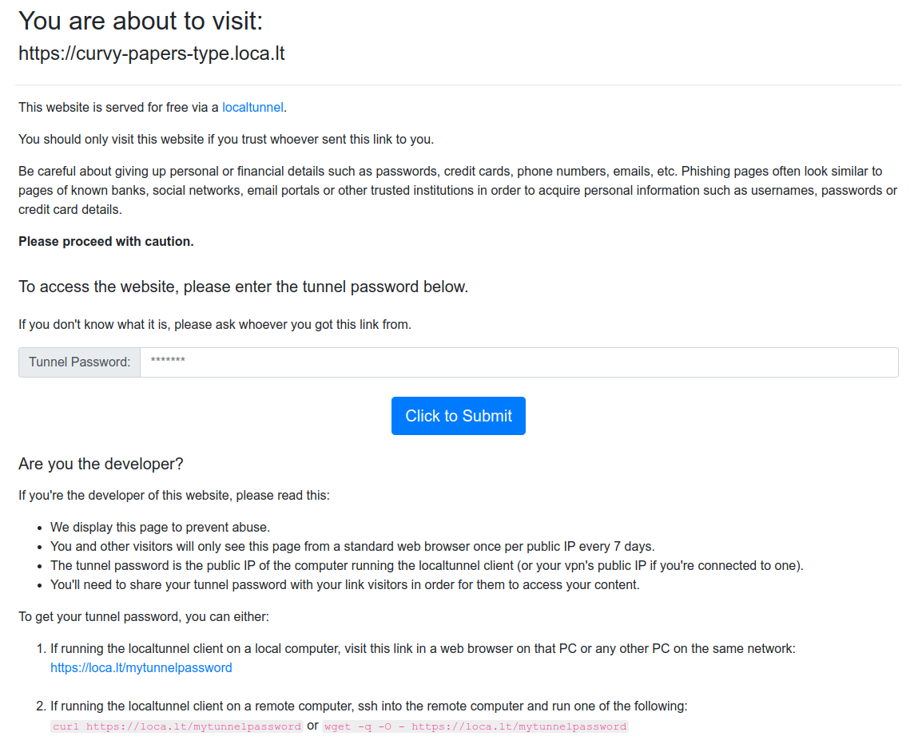  
  
Paste the password on the text field and click the “Click to Submit” button